EtherCAT Technology Group now offers vendor-independent diagnosis interface

The EtherCAT Technology Group (ETG) has specified a new vendor-independent diagnosis interface, which allows third-party tools to access diagnostic information from EtherCAT networks. The software-based interface can be implemented in controllers offered by any device manufacturer, which makes it an interesting feature to vendors of both master devices and diagnostic tools.

Diagnosis is one of the most important functions of a modern fieldbus system. EtherCAT provides extensive diagnostic information both at the hardware and software levels. An outstanding EtherCAT feature is the ability to not only detect errors but also to precisely locate them. This includes bit errors as well as issues generated by loose connectors. The corresponding error counters are supported by all network slave devices. This helps users, machine builders and system integrators ensure the robustness of EtherCAT networks and, as a result, reduce machine downtime to the absolute minimum. Furthermore, diagnostic routines test the quality of the communication and help easily detect internal errors in slaves, wrong cabling order, damaged cables or EMC interference.

ETG has specified this user-friendly, vendor-independent diagnosis interface so that third-party diagnostic tools can work with any master implementation. No hardware changes are necessary, since an EtherCAT master is software-based, as is the interface. The interface is easy to implement with a small software footprint, so it is even suitable for embedded devices with limited memory.

The standardized interface allows access to EtherCAT network diagnostic information for both hardware and software. Through the information provided by this new interface, diagnostic tools or HMIs can retrieve the EtherCAT network topology information, compare it with the expected configuration and detect communication interruptions and disturbances, as well as unexpected state changes.

The specification ETG.1510 “Profile for Master Diagnosis Interface” enhances the “EtherCAT Master Classes” specification and extends the EtherCAT Master Object Dictionary already defined in the “Modular Device Profile” specification. Likewise, the access mechanism makes use of the already specified Mailbox Gateway functionality. Based on already existing standards, the new profile is therefore easy and straightforward to implement.

Press picture:
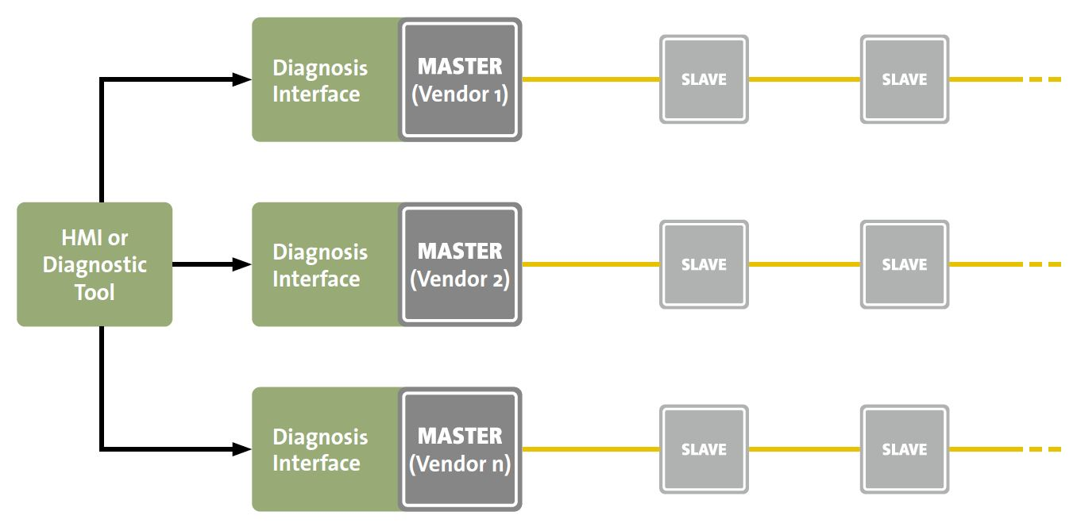
Link: www.ethercat.org/images/press/etg102018.jpg

Picture caption:
The diagnosis interface enables master-independent access to EtherCAT diagnostic data

About EtherCAT Technology Group (ETG):
The EtherCAT Technology Group is an organization in which key user companies from various industries and leading automation suppliers join forces to support, promote and advance the EtherCAT technology. With over 5,000 members from 65 countries the EtherCAT Technology Group has become the largest fieldbus organization in the world. Founded in November 2003, it is also the fastest growing fieldbus organization.

About EtherCAT®:
EtherCAT is the Industrial Ethernet technology which stands for high-performance, low-cost, easy to use with a flexible topology. It was introduced in 2003 and has been an international IEC standard and a SEMI standard since 2007. EtherCAT is an open technology: anyone can implement or use it.

- For further information please see: www.ethercat.org

Press contact:
EtherCAT Technology Group
Alina Krüger
Ostendstraße 196
90482 Nuremberg
Germany

Tel.: +49 (911) 5 40 56 226
Fax: +49 (911) 5 40 56 29
a.krueger@ethercat.org
www.ethercat.org/press

